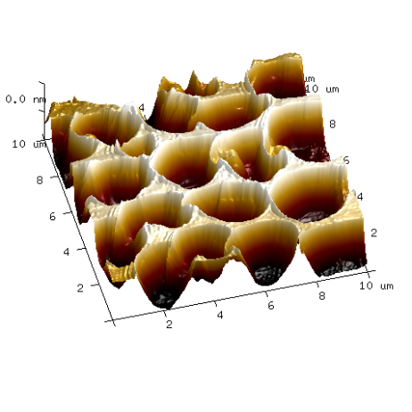
Gelation of Oils Using Polymers to Control Lipid Bioavailability and Lipophilic Bioactive Delivery
Dr. Alejandro G. Marangoni, O.C., O.Ont., F.R.S.C.
Department of Food Science
University of Guelph
Guelph, ON N1G 2W1
Canada

The structuring of edible oils into soft solid materials without relying on high concentrations of saturated or trans fats has emerged as an important strategy for developing healthier lipid-based foods and nutraceutical delivery systems. Among the different approaches to oil structuring, oleogelation using polymers is particularly promising because it produces stable, tunable networks capable of controlling mechanical properties, lipid digestion, and molecular release. This presentation will review the fundamentals of oleogelation and focus on our extensive work with ethylcellulose (EC), the best-established food-grade polymer capable of directly structuring edible oils.
The physical chemistry of EC oleogelation, including thermal dissolution, polymer–polymer interactions, network formation, rheological behaviour, and microstructure development, will be discussed. Particular attention will be given to strategies for tailoring gel properties through polymer molecular weight and concentration, oil composition, and the addition of surfactants, fatty acids, and fatty alcohols.
The ability of EC networks to regulate lipid digestion and absorption will then be examined. In vitro studies demonstrated that sufficiently strong EC networks markedly reduced lipid hydrolysis, whereas weaker networks behaved similarly to unstructured oil. Randomized crossover human studies subsequently showed that EC oleogelation strongly attenuated the six-hour postprandial plasma triglyceride response relative to the corresponding liquid oils. These effects were observed with coconut, palm, and rice-bran oils, demonstrating that the physical form of dietary fat can influence its acute biological availability without changing the amount or composition of the oil.
EC oleogels also provide a means of controlling the delivery of lipophilic bioactives. Using β-carotene as a model compound, oleogel structure was shown to regulate lipid hydrolysis and subsequent transfer of the bioactive into the aqueous micellar phase during digestion, while also providing protection against degradation during storage. We are now beginning to investigate EC oleogels as structured inks for three-dimensional food printing, creating the possibility of spatially organizing lipid phases, bioactives, and other food components within composite structures. Collectively, these findings position polymeric oleogels as a versatile platform for connecting food-material architecture with mechanical functionality, lipid bioavailability, and controlled delivery.

